Full Schedule

Part 1: FEASIBILITY ANALYSIS OF PROPOSED SOLUTIONS

1. Requirement Chart: Saturday 9th (NIGHT)
   * 10 requirements per person (be SUPER detailed and specific)
   * I know 10 per person is a lot but just in case we get doubles when we all do it separate
   * format must be given like follows but you only need the first two columns
     1. requirement reference and attribute. The rest will come once we put it altogether. (picture is form profs doc)
     2. 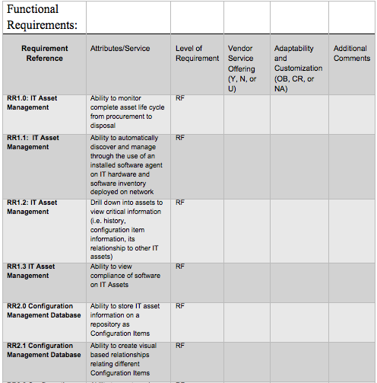
2. Vendor Profile – Tuesday 12th (NIGHT)
   * Around ½ or ¾ of a page
     1. Ragavi (wavebox)
     2. Keirn & Anthony (light screen)
     3. Emil & Duke (Netsoite)
3. Requirement Assessment – Sunday 17th (NIGHT)
   * Write about your company’s good and bad aspects like General Feasibility, Functional Feasibility and so on ¾ to a page
   * Give a score out of 50 for each section (check google doc for chart I already made)
   * Input only the raw score for now in chart cause the weight of each may change later
4. Cost benefit analysis – Wednesday 20th (NIGHT)
   * Check PDF and d2l for details and give examples
5. Risk Assessment – Saturday 23rd (NIGHT)
   * Check d2l and PDF for details
   * Must be ½ or ¾ of a page
   * Template on d2l, use as an example
     1. No need to do the chart at the end of the doc, just the explanation

Part 2: IMPLEMENTATION PLAN

* I will be updating this section in a week or so in terms of who is doing what and when its due.

1. Planning
2. Installation and Conversion
3. Testing
4. Training
5. Documentation

\*stay on top of these date and send them to me when completed and label the document according with your name so I know and wont get mixed up\*

\*\* We want 95% of this done by march 17th because we want to show her a week before its due to ensure its all good. We will try to meet with her in between to help with that too since it’s a lot \*\*

THANKS ☺